**Protocol for Monitoring Aquatic Invertebrates of Small Streams in the Heartland Inventory & Monitoring Network**

**SOP 5: Measuring Stream Discharge**

**Version 1.1 (9/1/2016)**

**Revision History Log:**

|  |  |  |  |  |  |
| --- | --- | --- | --- | --- | --- |
| Previous Version # | Revision Date | Author | Changes Made | Reason for Change | New Version # |
| 1.0 | 1 Sept 2016 | Bowles | FH950 flow mter added to equipement | Updated equipment inventory | 1.1 |
|  |  |  |  |  |  |
|  |  |  |  |  |  |
|  |  |  |  |  |  |
|  |  |  |  |  |  |

This SOP is guidance for measuring discharge in small streams. The SOP describes sampling procedures, calibration, and general maintenance procedures. Field personnel should review the instruction manual for instrument-specific guidance on how to calibrate and operate meters used to measure velocity.

1. **Background Information**

Velocity and depth are measured using a current meter attached to a wading rod. The rod allows for quick and easy measurements of depth with incremental markings, and has an adjustable arm that places the current meter at the proper depth for measuring velocity (60% of the depth from the surface of the water) (Carter and Davidian, 1969). Some current meters have rotating cups (Pygmy and Price models) while others have a pair of electronic contacts on a small head (FLO-MATE 2000 and HACH FH950) to measure velocity. Velocity is displayed as either feet per second or meters per second.

Stream discharge (Q) is the volume of water passing a cross-section per unit of time and is generally expressed in cubic feet per second (ft3/s) or cubic meters per second (m3/s). Discharge is estimated by multiplying current velocity by the cross-sectional area of the desired reach (Carter and Davidian, 1969). Cross sectional area is determined by first measuring the width of the stream channel. The cross section is then divided into smaller increments (usually 15 to 20 intervals) and depth and velocity are measured at each increment. The depth and width of the interval are multiplied to get an area for each interval and then each interval area and velocity are multiplied to produce a discharge for each interval. These discharges are summed to produce a total discharge for that cross section of the stream. This process will be described in greater, step-by-step detail in the “Procedures” section.

**II. Prior to the Field**

1. Standard wading rods are available in both metric and English standard units (feet). This protocol will use metric units for recording data. There must be consistency in units between the settings on the velocity meter, the wading rod, and the tape measure, and the units must be clearly recorded on the data sheet. If English standard units are used in the field, the data must be converted to metric units for data entry.

* 1. Ensure new batteries are placed in units that require them and additional batteries are

taken to the field as a back-up.

3. Calibrate velocity meters (FLO-MATE 2000, HACH FH950, USGS pygmy) according to instructions in the manufacturer’s operations manuals. Photocopies of the operations manuals should be taken to the field.

4. Equipment maintenance and storage will follow guidance issued by the manufacturers.

1. **In the Field**

Discharge measurements require wading across the stream and may stir up sediments, which disrupte accurate measurement of other parameters. Therefore, discharge should be the last measurement taken at a site.

Quantitative Discharge Procedure:

* + 1. Prior to taking any measurements, the location where discharge will be measured must be determined. An ideal cross-section in the sample reach will have the following characteristics:

1. The stream channel directly above and below the cross-section is straight.
2. There is measurable stream flow, with a stream depth preferably greater than 10 cm and velocities generally greater than 0.15 meter/second.
3. The streambed is a uniform “U” shape, free of large boulders, woody debris, and dense aquatic vegetation.
4. The stream flow is laminar and relatively uniform with no eddies, backwaters, or excessive turbulence.

Note: The cross section will not likely meet all these qualifications,

but the best location should be selected based on these standards.

Record (or draw a diagram) on the data sheet describing

any discrepancies within the cross section.

* + 1. Once the cross section is established, measure the width of the stream with a tape measure to the nearest 0.1 meter and secure the tape across the stream for the duration of the discharge measurement.
    2. Divide the stream into equal intervals across the width of the cross section, usually 15 to 20. A minimum of 10 intervals is recommended. A velocity and depth measurement will be recorded for each interval across the stream at the center of each interval. For example, if the stream is 10 meters wide, 10 velocity and depth measurements will be taken at one meter intervals (Fig. 1).
    3. Attach the sensor to the wading rod and ensure that the sensor is securely screwed onto the rod and faces upright.

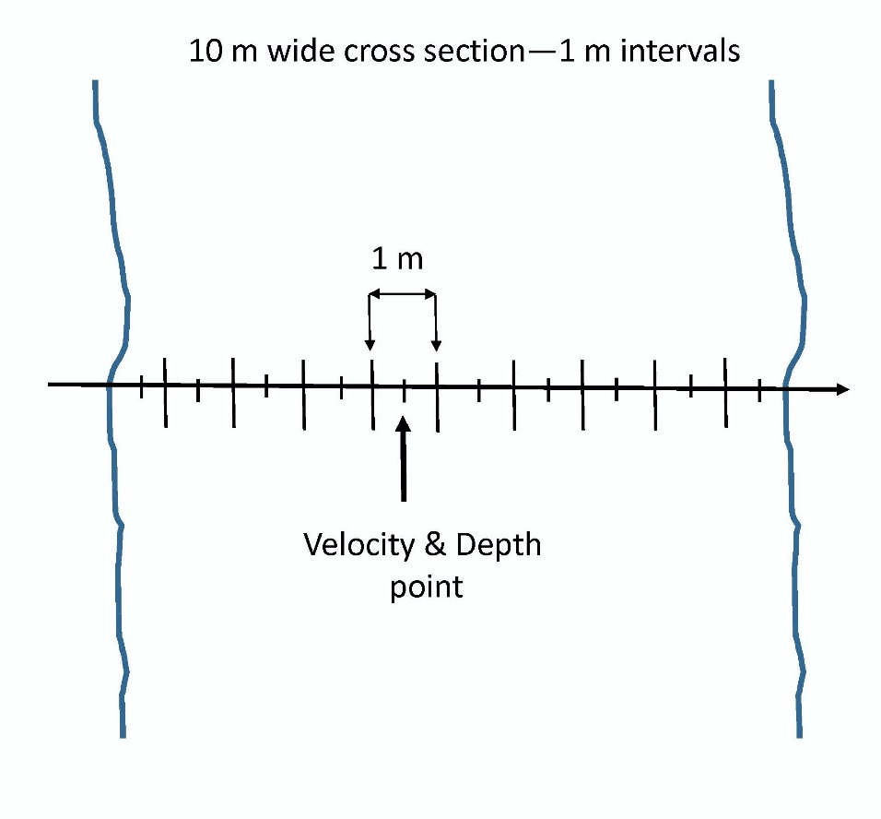

**Figure 1**. Cross section diagram.

* + 1. One person will measure discharge and one person will remain on the bank, recording data. The first data entry indicates water’s edge, and recorded as depth=0 and velocity =0. Proceed to the next interval and record readings. Place the wading rod as level as possible and hold perpendicular to the water level. Read depth from the wading rod to the nearest centimeter. The rod will have graduated marks along its length, with single marks indicating two centimeters, double marks indicating 10 centimeters, and triple marks indicating one-half meter increments.
    2. Once depth has been read, adjust the arm of the sliding rod with the sensor attached to 60% of the water depth. The wading rod will place the sensor at 60% of the depth from the surface of the water when properly adjusted.

Note: For example, if the depth is 2.6 meters, line up the 2 on the meter scale (sliding rod) with the 6 on the tenth scale (increments on handle of fixed rod). The sensor is now located at 60% of the water depth.

* + 1. Stand behind the sensor and make sure there is no disturbance (including the sensor cord) around the sensor that interferes with the velocity measurement. The meter may be adjusted slightly up or downstream to avoid boulders or other instream interferences.

Note: Make sure the sensor directly faces the flow of the water. This may not always be directly parallel with the stream bank. The rod and sensor may need to be turned slightly with each measurement.

* + 1. Allow the instrument enough time to get an accurate reading≈ one minute, or until the reading stabilizes. Watch the time bar complete two full cycles and then take the velocity reading. If something happens during the measurement, such as accidental movement of the wading rod, the reading will be repeated.
    2. Call out the distance from the water’s edge, the depth, and then the velocity to the person recording data. Continue moving across the stream until measurements have been taken at all intervals.

Note: If the water velocity increases greatly between intervals, additional measurements can be taken to shorten the width of the intervals within this area of high velocity. Be sure to change the interval width for these measurements in the calculation of discharge.

The ‘flag’ column on the form is used to record any relavant notes that could alter interpretation of the depth or velocity readings, such as the occurrence of fine sediment, large wood debris, aquatic vegetation, boulders, etc.

When finished, detach the sensor from the wading rod and place it back in the storage container for transportation. If the meter is not going to be used for several days, remove the batteries, clean the sensor, and store properly.

